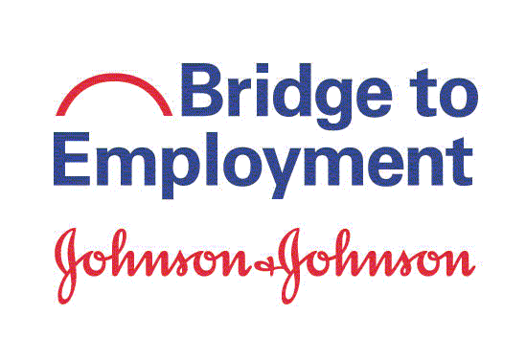

Thank you for taking this survey!

Instructions. Please take a few minutes to answer these questions. The information you provide will help improve the BTE program. Your individual information will be treated confidentially. Thank you!

About You

- Has a primary caregiver (parent or other guardian with whom you live) attended higher education (education beyond high school or secondary school – such as college, university, vocational training institutes, etc.)?
q Yes
q No
q Don’t Know / Not Applicable

For sites that focus on volunteering activities:
- (2a) Do you volunteer in your community outside of BTE or school requirements?

q Yes
q No

If yes, please check the type of volunteering activity that you do (check all that apply):

- Tutoring (of peers or younger students)
- Hospital/nursing home
- Animal shelter
- Food bank/soup kitchen
- Place of worship (church/temple/mosque)
- Local library
- Charity/non-profit organization
- Other, please specify:______________________________________________
next page . . .
How often do you take part in volunteer activities?

- Every day
- Once a week
- Twice a week
- Once a month
- A few times per year

For sites that do not focus on volunteering activities:
(2b) Do you participate in other extra-curricular activities outside of BTE or school requirements?

q Yes
q No

If yes, please describe the type of activities that you do:

How often do you participate in activities outside of BTE or school requirements?

- Every day
- Once a week
- Twice a week
- Once a month
- A few times per year

- During this school year, have you interacted with anyone at J&J [insert local operating name] for career advice?

- Yes
- No
- Not Sure

next page . . .

Your Knowledge about Education and Career

- To what extent do you agree with the following statements regarding your knowledge about higher education and career? Note: The term “higher education” means education beyond high school/secondary school. (Put an X in the box that describes how much you are aware of each item.)

I am aware of … | Not at all | Somewhat | A lot
- the educational opportunities available after high school / secondary school.
- the skills needed to achieve my educational goals.
- the process to apply to a higher education institution.
- the necessary courses/exams I need to complete to be accepted into a higher education institution
- extra-curricular activities that might benefit me in applying to a higher education institution (for example, clubs, leadership roles, student council)
- different careers in the health or STEM2D (Science, Technology, Engineering, Math, Manufacturing and Design) industries.
- the skills needed for health or STEM2D careers.

next page . . .

Your Readiness for Higher Education and Career

- To what extent do you agree with each of the following statements regarding your readiness about your education, career or general skills? Note: The term “higher education” means education beyond high school/secondary school; for example, a vocational school, trade school, college or university. (Put an X in the box that describes how confident you feel.)

I am confident that I can … | Not at all | Somewhat | A lot
- set my education or career goals
- determine steps to attain my education or career goals
- take the steps I need to take to get into higher education
- attend higher education
- find out about different careers
- choose a career that fits my interests
- prepare a good resume
- interview for a job
- make good decisions
- manage time well
- lead a group
- work well independently
- work well with others
- solve problems well
- innovate (have new ideas)

next page . . .

Your Plans and Steps Taken Towards Higher Education and Career

- To what extent do you agree with each of the following statements regarding your plans and steps taken to reach your education or career goals? Note: The term “higher education” means education beyond high school/secondary school; for example, a vocational school, trade school, college or university. (Put an X in the box that describes how you much you agree.)

I have … | Not at all | Somewhat | A lot
- set my education or career goals
- determined steps needed to attain my education or career goals
- plans to attend further education after high school/ secondary school
- acquired skills needed to achieve my educational goals
- plans to have a career (job) in health or STEM2D field

You’re done! Thank you!

