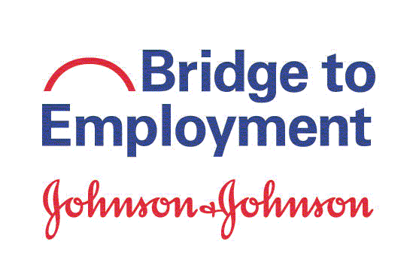

Thank you for taking this survey!

Instructions. Please take a few minutes to answer these questions. The information you provide will help improve the BTE program. Your individual information will be treated confidentially. Thank you!

About You

For sites that have focus on volunteering activities:
- (1a) Do you volunteer in your community outside of BTE or school requirements?

q Yes
q No

If yes, please check the type of volunteering activity that you do (check all that apply):
- Tutoring (of peers or younger students)
- Hospital/nursing home
- Animal shelter
- Food bank/soup kitchen
- Place of worship (church/temple/mosque)
- Local library
- Charity/non-profit organization
- Other, please specify:______________________________________________

How often do you take part in volunteer activities?
- Every day
- Once a week
- Twice a week
- Once a month
- A few times per year
next page . . .

About You Continued

For sites that do not focus on volunteering activities:
1. (1b) Do you participate in other activities outside of BTE or school requirements?

q Yes
q No

If yes, please describe the type of activities that you do:

How often do you participate in activities outside of BTE or school requirements?

- Every day
- Once a week
- Twice a week
- Once a month
- A few times per year

- During this school year, have you interacted with anyone at J&J [insert local operating name] for career advice?

q Yes
q No
q Not sure

next page . . .

Your Knowledge about Education and Career

- To what extent do you agree with the following statements regarding your knowledge about higher education and career? Note: The term “higher education” means education beyond high school/secondary school. (Put an X in the box that describes how much you are aware of each item.)

I am aware of … | Not at all | Somewhat | A lot
- the educational opportunities available after high school / secondary school.
- the skills needed to achieve my educational goals.
- the process to apply to a higher education institution.
- the necessary courses/exams I need to complete to be accepted into a higher education institution
- extra-curricular activities that might benefit me in applying to a higher education institution (for example, clubs, leadership roles, student council)
- different careers in the health or STEM2D (Science, Technology, Engineering, Math, Manufacturing and Design) industries.
- the skills needed for health or STEM2D careers.

next page . . .

Your Readiness for Higher Education and Career

- To what extent do you agree with each of the following statements regarding your readiness about your education, career, or general skills? Note: The term “higher education” means education beyond high school/secondary school; for example, a vocational school, trade school, college, or university. (Put an X in the box that describes how confident you feel.)

I am confident that I can … | Not at all | Somewhat | A lot
- set my education or career goals
- determine steps to attain my education or career goals
- take the steps I need to take to get into higher education
- attend higher education
- find out about different careers
- choose a career that fits my interests
- prepare a good resume
- interview for a job
- make good decisions
- manage time well
- lead a group
- work well independently
- work well with others
- solve problems well
- innovate (have new ideas)

next page . . .

Your Plans and Steps Taken Towards Higher Education and Career

- To what extent do you agree with each of the following statements regarding your plans and steps taken to reach your education or career goals? Note: The term “higher education” means education beyond high school/secondary school; for example, a vocational school, trade school, college, or university. (Put an X in the box that describes how you much you agree.)

I have … | Not at all | Somewhat | A lot
- set my education or career goals
- determined steps needed to attain my education or career goals
- plans to attend further education after high school/ secondary school
- acquired skills needed to achieve my educational goals
- plans to have a career (job) in health or STEM2D field

Your BTE Experiences

- Reflecting on your experience in the BTE program in the past year, to what extent do you agree with the following statements regarding your perception about the impact of BTE? (Put an X in the box that describes how much you agree.)

The BTE program has… | Not at all | Somewhat | A lot
- made me aware of the steps I need to take to work in the health or STEM2D fields.
- motivated me to work harder in school.
- helped me to feel good about my future.
- prepared me to achieve my career goals.

You’re Done! Thank you!

