Some Tips on What to Do and Where to Start
Please refer to the lists below for general guidance on successfully communicating your site’s impact and successes.
Branding and the Comms Toolkit
- Refer to the Style Guide for BTE’s brand colors, fonts, and how to layout a Word doc using BTE branding. Additionally, the guide contains an example of how to co-brand, adding your logo to the corner opposite from BTE’s logo.

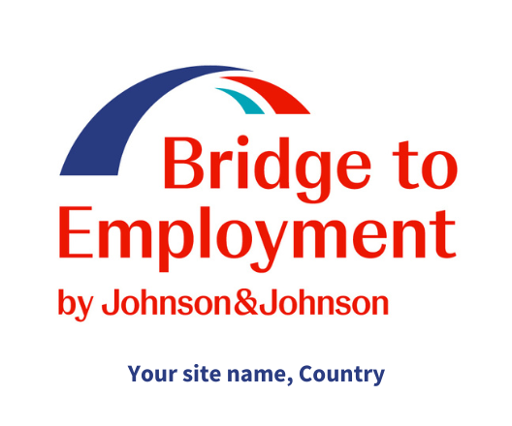
BTE Logo Example
- You can use the logos, brand elements, and colors to help your site match the look and feel of BTE global.
- DO NOT alter the BTE logo. You can add your site name underneath the logo, as seen in the example to the right.
- If the FHI 360 logo is present, do not remove it. If you have further questions about the FHI 360 logo, please contact us!
- Use the PowerPoint template, photos, and additional items in the toolkit to help you get your site’s communications started.
- If you need assistance designing or producing additional materials, please reach out to FHI 360.

Social Media
- Your organization may already have social media accounts. You can use those to share events, photos, and information about your BTE program.
- If you do not have social media accounts, or want one specifically dedicated to BTE, we recommend starting with an Instagram account. If you have not managed an Instagram account before, there are many resources online to help you get started.
- Follow BTE! You can find us: @BTEgrams, @BTEtweets, https://www.facebook.com/jandjbridgetoemployment, and https://www.linkedin.com/company/bridge-to-employment/
- Use the hashtag #jnjbte for BTE content, #jnjPathways for Pathway to Success content. Use any other hashtags relevant to your post, such as #STEM for a STEM activity.
- Tag your partners. If you visit a university campus, tag that school in your post. If Johnson & Johnson volunteers join your event, tag your J&J partner or even the individual volunteers, if they share their information with you.
- Make sure you have photo release forms from your students before you share their images online! DO NOT share their pictures if you do not have permission.

BTE Website (Site Page)
- Don’t forget the BTE website is a great place for you to share event info, documents & resources, and program updates with your participants, parents, volunteers, and other stakeholders.
- After your website training, make sure you update your site page each month with an activity you did the previous month and events that are upcoming.
- Direct your participants to the page regularly for information.
- You can link any social media accounts to your site page
- You can also direct people to your site page via social media, although only some parts of the site page will be publicly visible.
- Keep up with global BTE events and news via the website, too! Visit: https://www.bridge2employment.org/

At any point, please feel free to reach out to the FHI 360 team for information and assistance with communications: bte@fhi360.org.

