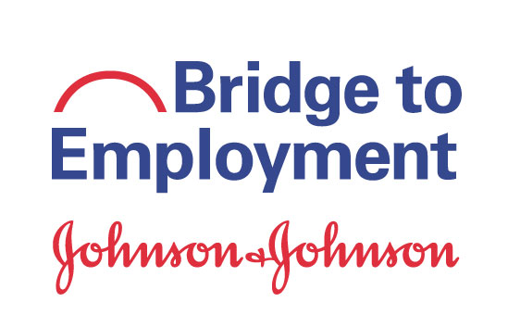
Sustainability Work Plan

Overview. The Sustainability Work Plan serves as a road map of action steps for sustaining the BTE program activities. The Sustainability Work Plan is completed in partnership with FHI 360 during Year 2 or Year 3 of the BTE program.

Name of Program:
Completed By:
Date:

Sustainability Goal. We plan to sustain the BTE program...
£ At the current level £ At a reduced level £ As a variation of current program £ Other:

Program Details:
Target population:
Length of program (# of years):
Location:
Partners:
Sustainability Champion:
(Organization and specific person to lead the team’s sustainability efforts)

Program Activities to Sustain. Please list the BTE Program Activities the site hopes to sustain. Tip! Use the SCORE analysis, the BTE Program Model, and the site’s independent evaluation results to identify program activities that have the most impact.

Outcomes: What outcomes do you hope to achieve through these activities? How will you know if you have achieved them?

Funding. Is funding required to sustain the program activities? If so, how much?

Action Step  What do you need to do to sustain this program activity? | Benchmarks/ Milestones/ Indictors of progress | Person Responsible | Timeframe | Indicators of Progress/Notes
Review and/or obtain commitments from current partner organizations | Determine future roles/responsibilities of current partners
 | Identify other efforts within current organization with whom to partner/ align
 | Meet with representatives from current partner organizations
 | Initiate request for future funding (monetary & in-kind)
 | Identify groups in the area or outside the area with similar scope
 | Meet with groups to discuss potential partnerships

Action Step  What do you need to do to sustain this program activity? | Benchmarks/ Milestones/ Indictors of progress | Person Responsible | Timeframe | Indicators of Progress/Notes
Diversify funding sources (monetary or in-kind) | Identify new potential funders  - Databases identified or research completed  - List foundations  - Private industry  - State, local and/or federal
Contact potential funders via letters of interest, calls or meetings
- Number of letters issued
- Number of calls made
- Number of meetings held
Complete and submit applications for funding
- Number of applications completed
- Number of applications receiving call back or follow up from funder
 | Explore Alternative Funding

