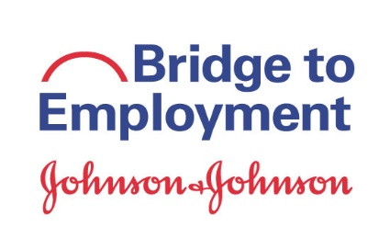
SCORE
SCORE Exercise: Prior to undertaking sustainability planning, it is important to reflect on the program – what worked well, what needs to be improved, how can it be modified, etc.? The chart below helps identify key areas of promise and possibility to inform the sustainability process.
Strengths | Options
What is our program known for?  What activities have the most impact? What are the key things to continue?  What did the independent evaluation reveal?  What resources do we have available to us? (Including strong partnerships with other organizations)  What support do we have from others?  Are there high/satisfactory levels of volunteer engagement/involvement? | Which sustainability model appeals most to you?  What are our options for sustainable program design?  -Program length?  -Target population?  -Where will BTE occur?  How would we implement this? (e.g., do we need an NGO?)  Are there new potential partners or funders?  What changes would make the program even better?
Capabilities & Costs | Responses
What new capabilities and services would we need?  How much would this cost? What resources are needed?  How much of the projected costs could be covered in-kind support? | What issues would we need to address (with partners, other stakeholders)?  How should we prioritize these options and actions?  What responses would we expect from stakeholders?  -from the local operating company  -from the schools  -from partners  -from students  Where could we go to secure the required funding?
Evaluate
Based on our SCOR results...are we moving forward?

If yes, use Sustainability Work Plan to record next steps
*SCORE done at a Partner Meeting; following individual calls with each partner to review homework/readiness for sustainability
Start process after Year 2 evaluation focus group debrief.

