ALLIANCE BUILDING AND TRAINING SESSION 2021
AGENDA AT-A-GLANCE

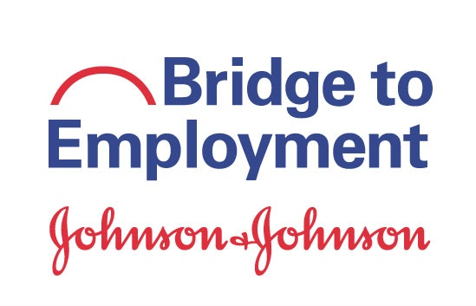
day 1: MONDAY, october 25, 2021

EVENING & NIGHT SESSIONS
8:00 pm – 9:00 pM EST | Opening Session  - Welcome & Opening Remarks  - Site Introductions & Icebreaker
9:00 pm – 9:45 pM EST | E-Learning Module Discussion: Positive Youth Development
10:00 PM – 11:00 PM est | BTE Now & Then Panel – Live Event!
11:00 pm – 12:00 aM EST | Regional Team Meeting: Sites in Asia Pacific

ABTS 2021 Agenda At-A-Glance

DAY 2: tUESDAY, OCTOBER 26, 2021
MORNING & AFTERNOON SESSIONS
6:00 AM – 7:00 aM EST | Regional Meeting: Sites in Europe and Africa
7:00 AM – 7:45 aM EST | Speed Networking (Optional)
9:00 AM – 9:45 AM EST | Virtual Activity Showcase (choose one option below)  - Engaging Students + Stakeholders using Social Media & LinkedIn  - Live Surgery Virtual Demonstration  - Digital Badges  - Cotton Ball Catapult Competition Demonstration
10:00 AM – 10:45 AM EST | BTE Student Speed Networking – Open to all BTE Students! (Optional)
11:00 AM – 11:45 AM EST | Role Alike Sessions  - BTE Champions Meeting  - BTE Site Coordinators Meeting  - Secondary School / Educator Meeting
12:00 pM – 12:45 pM EST | Site Meetings by Year: Years 2 and 3 only  - Year 2: Franklin Township, New Jersey; Nigua, Dominican Republic; Orange County, California; Puebla, Mexico; Tswelopele, South Africa  - Year 3: Athens, Georgia; Helsingborg, Sweden; High Wycombe, United Kingdom; Limerick, Ireland
1:00 pM – 2:00 pM EST | Johnson & Johnson Diversity, Equity, & Inclusion Initiatives
2:00 pM – 2:45 pM EST | Resiliency: Stories from Around the World (Optional)
3:00 pM – 4:00 pM EST | Site Spotlights
ABTS 2021 Agenda At-A-Glance
EVENING & NIGHT SESSIONS
7:00 PM – 7:45 pM EST | BTE Student Speed Networking – Open to all BTE Students! (Optional)
7:00 PM – 7:45 pM EST | Adult Speed Networking – Open to all J&J employees who volunteer with local BTE programs (Optional)
9:00 PM – 9:45 pM EST | Role Alike Sessions  - BTE Champions Meeting  - BTE Site Coordinators Meeting  - Secondary School / Educator Meeting
ABTS 2021 Agenda At-A-Glance
DAY 2, CONTINUED
10:00 PM – 10:45 pM EST | Virtual Activity Showcase: Live Surgery Demonstration
10:45 – 11:30 PM EST | Lessons Learned: Program Kickoff

DAY 3: WEDNESDAY, OCTOBER 27, 2021
MORNING & AFTERNOON SESSIONS
7:00 AM – 8:00 aM EST | Site Meetings by Year: Strategic Planning and Year 1 only  Bangkok, Thailand; Englewood, Florida; Ewing, New Jersey; Lancaster, Pennsylvania; New York City, New York; Philadelphia, Pennsylvania; Prague, Czech Republic; São José dos Campos, Brazil; Singapore; Sydney, Australia; Warsaw, Indiana
9:00 AM – 9:45 aM EST | Guided Mindfulness / Reflection (Optional)
10:00 AM – 11:00 aM EST | The Neuroscience of Leading: How to Help Future Leaders Thrive and Build Resilience
12:00 pm – 12:30 pm est | Chew & Chat: Envisioning BTE in 2052
1:00 pm – 2:30 pm est | Student Ambassador Showcase – Live Event!
2:45 PM – 3:30 PM EST | Individual Site Meetings
3:30 PM – 3:45 PM EST | Event Wrap Up

evening & night SESSIONS
9:00 pM – 10:00 pM EST | The Neuroscience of Leading: How to Help Future Leaders Thrive and Build Resilience
10:00 pM – 11:00 pM EST | Student Ambassador Showcase
11:00 PM – 11:15 PM EST | Event Wrap Up
ABTS 2021 Agenda At-A-Glance

