|  |  |  |
| --- | --- | --- |
| BTE SITE SPOTLIGHT A GLIMPSE INTO YOUR BTE PROGRAMVIRTUAL COMMUNICATION DIGITAL BADGEPRE-WORK ASSIGNMENT | | |
| **DUE:**  ENTER DUE DATE | In an effort to prepare for your Virtual Communication Digital Badge, complete the following pre-work assignment. Work together with a partner from your site to create a 1-2 minute video that spotlights your local BTE program. You are welcome to include photos, video interviews, or anything else that helps capture your program, community, and other insights you would like the world to know about your BTE site and activities. EMAIL TO: ENTER CONTACT INFO | ENTER TI ME PREWORK IS DUE |
|  | | |

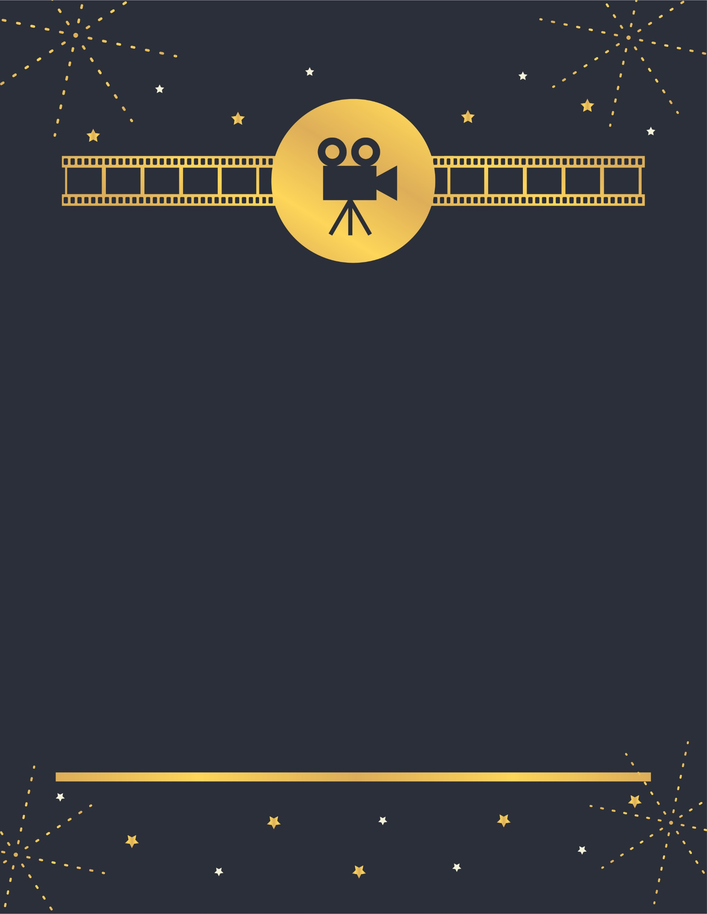

Note: Please use whatever resources you have readily available to make this video. This video should be student made and not intended for professional production. You should only use equipment available to you (i.e., cell phone, camera, free editing software online, etc.). Students should not incur any costs for the production of this video. Most importantly, have fun!

