

**© 2020 by FHI 360**

**decEMBER 2020**

**EDUCATION & CAREER PLAN**

AN ONLINE STRATEGY FOR SUCCESS

# education & career plan (ECP) Overview

# FHI 360 has created a high impact digital tool for students to use with their Navigators—the people in their lives who help them with their college and career planning. Navigators can include parents, teachers, counselors, advisors, or any other adults helping young people navigate their paths. The Education & Career Plan (ECP) is a user-friendly digital tool that builds on FHI 360’s [College and Career Readiness: A Guide for Navigators](http://ccrguide.wpengine.com/wp-content/uploads/2019/03/College-and-Career-Readiness.A-Guide-for-Navigators.pdf), which helps both students and Navigators map and track the college- and career-readiness journey. Four versions of the ECP are available, designed to support students pursuing different paths: those in high school, students in 2–year college programs, students in 4–year college and university programs, and those enrolled in certificate programs. Targeted to 21st century needs, the ECP is a living document that integrates college- and career-readiness exploration and preparation in one organized place.

# By connecting college and career plans, the ECP helps young people:

# Identify career interests and goals

# Connect career goals with specific qualifications, education, and training required for entry into those careers

# Outline a course plan that helps them meet postsecondary education and career goals

# Record activities and accomplishments in both college readiness and career readiness

## Education & Career Plan Collection

Below are brief descriptions of the four ECP versions. A hyperlink to each specific ECP template is provided within each header, along with an overview and section outline. Two Quick Guides accompany each ECP. One is for Navigators and one is for students. Both provide step-by-step instructions and recommendations for success. To learn more about these templates, or how you can partner with FHI 360, please contact [niwl@fhi360.org](mailto:niwl@fhi360.org).

### [High School ECP](https://docs.google.com/spreadsheets/d/1q8j9_WBuBwILi4_We2HrgxKaNGibsrcL0ZM4dj_UxBI/edit#gid=541890420)

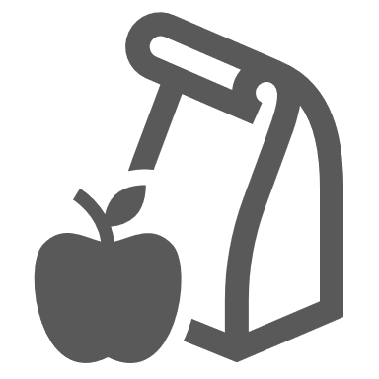Designed for students in grades 9–12, this version of the ECP is organized into **four sections** that focus on: (1) goal setting, (2) academic progress and accomplishments, (3) career exploration, and (4) postsecondary readiness. Additional resources and information pertaining to postsecondary applications, testing, and financial aid are also included, along with a Resources Roadmap that provides a list of useful links and common resources needed during postsecondary exploration and planning.

### [Certificate ECP](https://docs.google.com/spreadsheets/d/1fKPvyhmeu-2sSw_I4JFt2FXMNl4Z5Tbnsp0gZbhdfvM/edit#gid=541890420)

Designed for students enrolled in a certificate program, this version of the ECP is organized into **five sections** that focus on: (1) feedback and insights from diverse Navigators, (2) education and career goal setting, (3) academic progress and accomplishments, (4) career exploration progress and accomplishments, and (5) career readiness progress and accomplishments. A Resources Roadmap features common people, places, and informational tools utilized on a higher education campus.

### [2–Year College ECP](https://docs.google.com/spreadsheets/d/1bnuV8wQZV7us4BOVHg3kh346OMlMcz52iI32R0rJpSU/edit#gid=541890420)

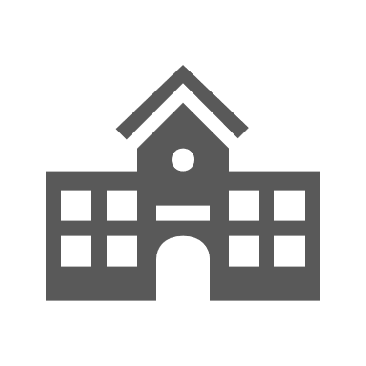Designed for students enrolled in a 2–year or community college, this version of the ECP includes information and resources related to 2–year plans and considerations for transfer. It is organized into **six sections** that focus on: (1) feedback and insights from diverse Navigators, (2) education and career goal setting, (3) academic progress and accomplishments, (4) career exploration progress and accomplishments, (5) career readiness progress and accomplishments, and (6) preparing for transfer. Additional readings and references regarding the transfer process are provided for those interested, along with a Resources Roadmap that features common resources found on a college campus and space to track key contact information and appointments.

### Graduation cap[4–Year College or University ECP](https://docs.google.com/spreadsheets/d/1HBBWGHpEcLrYOoDvj6PkkmN9OAHXLDeqs63YnFMwo5o/edit#gid=541890420)

Designed for students enrolled in a 4–year college or university, this version of the ECP includes information for course planning and career exploration as well campus resources and other organizational tools—including a Biology, Chemistry, Physics, and Math tracker for those on a medical path. It is organized into **five sections** that focus on: (1) feedback and insights from diverse Navigators, (2) education and career goal setting, (3) academic progress and accomplishments, (4) career exploration progress and accomplishments, and (5) career readiness progress and accomplishments.