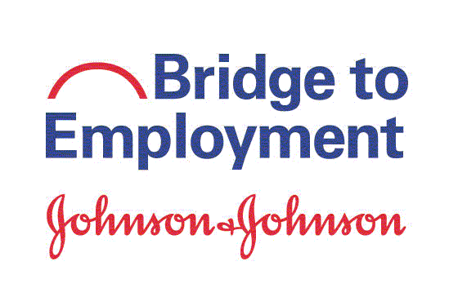
NGO or School Logo
Bridge to Employment Coaching Guide
Enter bte site name here
date

Program partners:
Text line one goes here
Second line goes right here

Table of Contents
Heading 1 Style Looks Like This 3
Heading 2 Style Looks Like This 3
Heading 3 Style Looks Like This 3
Heading 2 Style Looks Like This 4

Introduction
Provide a brief introduction of the BTE Coaching Guide, resources included, and intended use.

About Bridge to Employment
This The three-year program seeks to increase the number of young people enrolling in, attending, and completing higher education and pursuing Science, Technology, Engineering, Mathematics, Manufacturing, and Design (STEM2D) careers. The partners will provide a variety of academic enrichment, career exploration and readiness, higher education exploration & preparation, and community engagement and leadership opportunities

Partnership
Provide an overview of program partners collaborating on the BTE program:
- Johnson & Johnson local operating company
- NGO
- Institution of Higher Education
- School district

Community
Provide an overview of the community in which the BTE program is serving. Information can include community demographics, school report card, and any other information that would be helpful for volunteers to gain perspective on the community where their young people come from.
Language
X%
  - Ethnicity
X%

  - first generation
X%

High school graduation rate
X%

Academic Structure
Provide an overview of the school district in which the BTE program is serving, as well as any important information pertaining to academic structure. Information can include details regarding school academies, honors and AP opportunities, and special programs offered.

Program Model
Provide an overview of your site’s BTE program model (i.e., logic model). Information can include cohort size, program length, program outcomes, and general program activities. The leadership team may wish to include their site’s logic model that was developed during strategic planning and submitted with their grant application.

Program Activities
Provide an overview of the specific program activities students and volunteers will engage in. Activities may include advising, college tours, company tours, workshops, guest speakers, and projects. Refer to your site’s program model and include activities planned for the three-year program.
Academic Enrichment | Career Exploration | Higher Education Preparation | Community Building & Engagement

Golden Rules
Outline any expectations or “golden rules” that your leadership has developed to help ensure a smooth-running BTE program. Sample golden rules may include:

Communication Boundaries
Provide specific information pertaining to how volunteers should communicate with students enrolled in the program. Be explicit regarding any communication boundaries the leadership team has developed to ensure compliance with all partner policies and protocols, as well as student and volunteer safety. Potential guidelines may include:
- All email communications with students should include the Site Coordinator and Champion on the CC line.
- Do not share your cell phone or social media information.
- Do not text students. All electronic communication should be via email or by phone.
- Notify the BTE Champion and Site Coordinator if a student expresses an interest in meeting outside of planned coaching sessions.

Sample Career Coaching Agenda
If your site’s Johnson & Johnson volunteers will be conducting workshops or planning activities for the students enrolled in the BTE program, provide them with a standard template that ensures all event logistics are included and planned for.

Agenda Item | Description
Introduction  Presenter Name | Opening Remarks, community agreements, etc.  Location: Main Room
Warm-Up  Presenter Name | Games, Icebreakers, Poll Questions, etc.  Location: Main Room or Breakout Rooms  Example: Word Cloud- What feelings come to mind when you think about the future?
Opening Questions  Presenter Name | Brief “getting to know you” questions to open up the rest of the coaching session  Location: Breakout Room  Example: As a child, what did you want to be when you grew up?
BTE Segment Discussion  Presenter Name | This is an opportunity to discuss a recent activity you have been doing in the program.  Location: Breakout Room  Example: Discuss Birkman Assessment results. Discussion questions will be provided.
Uplifting Circle  Presenter Name | This is an opportunity for coaches and students to share any words of encourage and appreciation for sharing time and space together.  Location: Breakout Room and/or Main Room  Coach Example: Continue to follow the dreams you shared with us today. I believe you can succeed!  Student Example: Thank you for taking the time to speak with us today.
Closing Remarks  Presenter Name | Debrief in larger group, announcements, and final reminders  Location: Main Room

