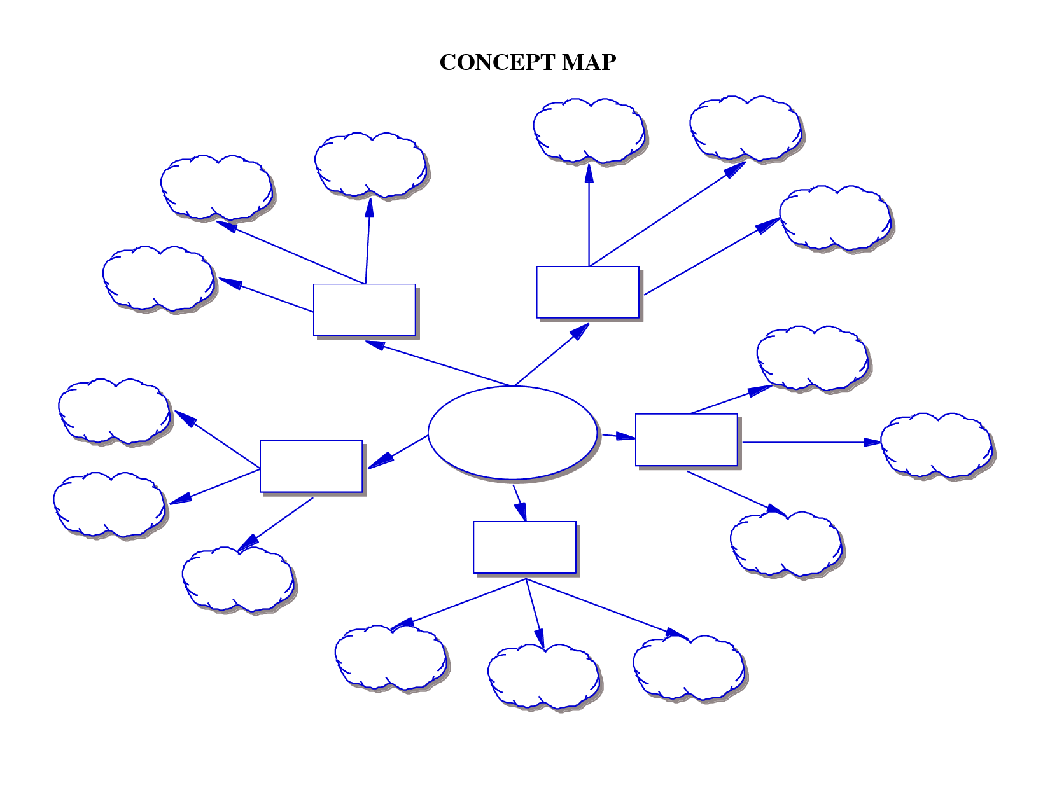

**Mind-Map Template**