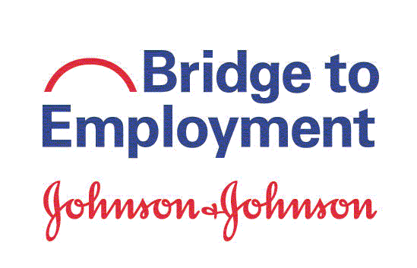

Alliance Building and Training Session Permission Form
If selected as a Student Ambassador, your child will be attending the Alliance Building and Training Session (ABTS). Johnson & Johnson's Alliance Building & Training Session (ABTS) is an annual professional development, learning, networking, and cross-site sharing conference for Bridge to Employment (BTE) partners. This is not a school-sponsored event; it is hosted by FHI 360 and Johnson & Johnson. Approximately 100 local operating company representatives, educators, and community leaders, and students from around the world gather to share experiences and learn about effective programs and best practices. Student Ambassadors are an integral component of the ABTS.

Date | October 2-4, 2019
Location | New Brunswick, New Jersey, USA
Cost | FHI 360 will cover travel costs associated with ABTS attendance, including  airline ticket, lodging, meals, and health insurance.
Chaperones | The BTE Site Coordinator will chaperone and supervise students at all times during travel to and from the ABTS. The BTE Site Coordinator and FHI 360 staff will chaperone students throughout their stay in New Jersey.

Please return this permission slip by: March 20, 2019

I give permission for my child
to attend ABTS from October 2-4, 2019 in New Brunswick, New Jersey. I approve of my child traveling under the supervision of BTE personnel. I acknowledge that the ABTS is not a school-sponsored event and understand that my child may incur unexcused absences from school for his/her participation.
In case of an emergency, I give permission for my child to receive medical treatment. In case of such an emergency, please contact:

Print Name

Phone Email:

Parent/Guardian Signature Date

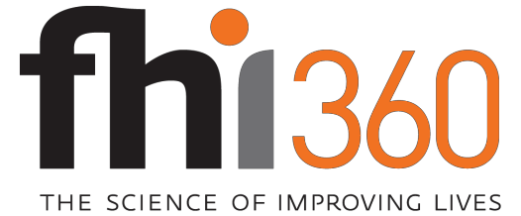

Permission to Use Pictures and/or Story

AGREEMENT
I agree to allow FHI 360 and/or its partners to publish, copyright, and use pictures of me and/or my story in print and electronic formats such as publications, videos, projects, and websites that help advance public health and development initiatives. I understand that my picture or story may be published in any of these media without restriction.

I understand that I will not receive payment or other compensation for use of my story or photos.

Signature | Date
Print Subject’s name
Subject’s Address
Parent/Legal Guardian (if under age 18) | Date

FHI 360 is a trade name of Family Health International

