Scenario 1: Rural Education in Indonesia
Around the world, statistics show that education directly affects a child’s development and future livelihood.
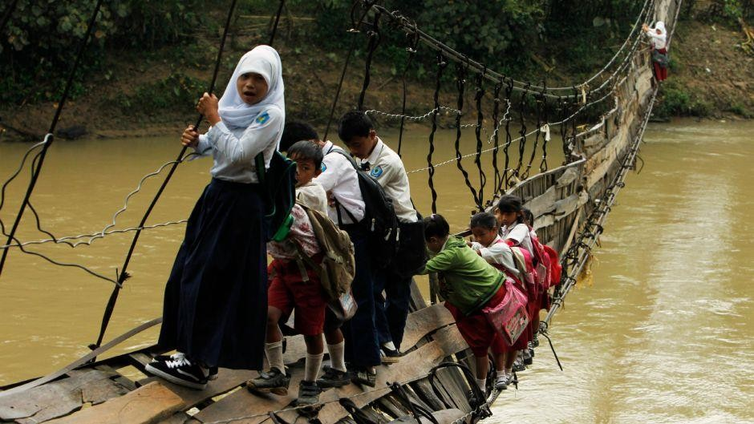
Primary education is key to a child's entry into an institute of higher education, vocational training and also employment. In developing, low-income countries, every additional year of education can increase a person’s future income by an average of 10%. As of 2012, 31 million primary-school pupils worldwide dropped out of school. In rural communities, there are many reasons for this occurrence:
- Students must take a long bus ride home or walk miles to get to school along a dangerous route in rural communities.

- Parents may not have enough information to assess the benefits of their children's education accurately. They may feel that more competitive urban job markets are too far from the community for the family to consider, so sending a child to school is not worth the effort.

- Children stay at home to assist families with farming, fishing, and other household tasks.
Some of these communities can be found in the coastal regions of Indonesia, like the Bulukumba regency, in South Sulawesi and Sekadau, and Bengkayang regency, in West Kalimantan and Sanghiang Tanjung, Suro Village.
Design a community service project that you think would benefit this community. Keep in mind the cultural and societal need for children to be able to work at home sometimes. Provide statistical support from your research showing why your project would work.

Scenario 2: Gangs in the Metropolitan United States
According to statistics, every city in the United States with at least 250,000 people has gang related activity, and about 85% of serious gang activity is concentrated in metropolitan areas in the United States.
Examples of some of these cities are Detroit, Michigan, St. Louis, Missouri and, Oakland, California.
Statistics further show that in the United States 40% of gangs are juveniles under the age of eighteen. Another study found that an average of 2% of youth in the U.S. are gang members, with involvement highest among youth at the age of fourteen years old. According to some social scientists, some factors that cause a rise in the number of gangs include - school failure and truancy, lack of involvement in positive activities outside of school, low income households, early involvement in petty theft and lack of adult support and guidance. They also imply that with mentoring and even tutoring increases student potential for growth and success greatly.
Work with you team to develop a community service project that you think will address this issue among young people in metropolitan cities in the US. Be sure to consider the fourteen-year-old age group, as this group has the highest gang participation rate among youth. Provide statistical support showing why your project would work.

Scenario 3: Pollution in Coastal Argentina
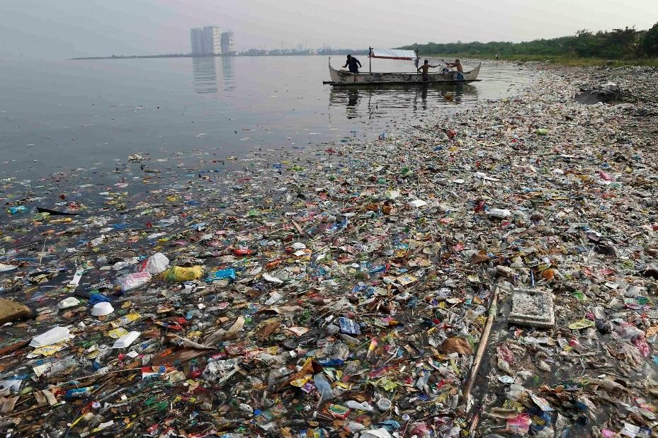
While our world is full of many large industrial cities, in many countries there are small, fishing communities built along river banks and coastal regions.
A fishing community is a community that is dependent on and fully engaged in, the harvest or processing of fishery resources to meet social and economic needs.

Argentina has many fishing communities. Unfortunately, these coastal communities suffer hardships due to pollution and contamination of the land and water along their coasts. Buenos Aires alone produces 5,000 tons of trash per day.
Due to overflowing landfills, a lack of recycling, and limited information on conservation, trash ends up in the streets and the local waterways. In fact, marine litter can travel long distances with the currents and winds. Not only does this litter directly affect marine life and birds, but it also washes onto beaches, is caught in fishing nets, damages boat motors, is an eyesore, and smells bad. Plastic bags and plastic wrap can asphyxiate marine animals and fish, and birds can easily entangle themselves in plastic strings. Land litter such as cigarette butts, old tires and food wrappers destroy coral reefs, harm animals and contaminate water. They also cause algal blooms in water which reduces the amount of available oxygen for aquatic life. Additionally, residents of these communities often become sick from the landfills and need to be hospitalized.
There is not enough awareness of the long-term, harmful effects a pollution causes to the oceans.
Design a community service project that you think will be able to help the citizens of these communities and also have a long-term, positive impact on their life and environment. Provide statistical support showing why your project would work.

