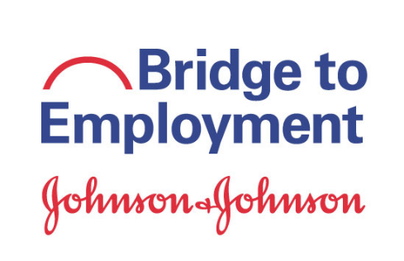**BTE-Phoenixville Activity Evaluation**

**Activity: Year 2 Kickoff**

**Date: September 20**

**Location: PAHS**

**Student’s Name (optional):_______________________________________________**

**Check the boxes below indicating if you strongly agree, agree, disagree, or strongly disagree with the following statements:**

|  |  |  |  |  |
| --- | --- | --- | --- | --- |
|  | Strongly Agree | Agree | Disagree | Strongly Disagree |
| I know what we will be doing in BTE-Phoenixville Year 2. |  |  |  |  |
| I got to know my BTE peers a little better today |  |  |  |  |
| I got to know BTE Career Coaches a little better today. |  |  |  |  |
| This activity was engaging. (I did not get bored!) |  |  |  |  |

**Please list 1 or 2 things you learned today:**

**1.**

**2.**

**Rate the overall effectiveness of this activity based on the options below:**

* **Loved it.** Through this activity, I was definitely able to explore potential careers and/or prepare for post-high school education/work.

* **Liked it.** Through this activity, I was somewhat able to explore potential careers and/or prepare for post-high school education/work.
* **Needs improvement.** I was not able to explore potential careers and/or prepare for post-high school education/work with this activity.

**If you chose “Loved it,” what did you enjoy most?**

**If you did not choose “Loved it” in your overall rating, please take a moment to explain why you thought the activity did not fully meet the goal of career exploration and/or college preparation.**

**Please share with us any other comments you have regarding the activity.**

**Do you have any questions regarding the activity or the program? (If you print your first and last names on the paper we will respond to you directly.)**

**Thank you again for your comments!**