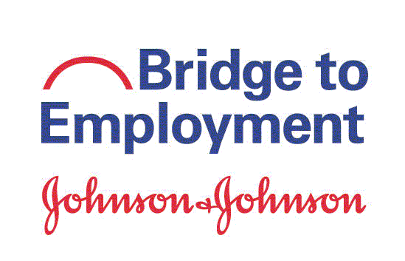

Thank you for taking this survey!

Instructions. Please take a few minutes to answer these questions. The information you provide will help improve the BTE program. Your individual information will be treated confidentially. Thank you!

About You

- Do you participate in any activities other than BTE? (check all that apply and write the name of each activity)
Clubs:
(for example, Boy Scouts, music/drama, math, language)
Religious activity:
Sports team:
Part-time job:
Tutoring:
Volunteering:
Other:
None (I do not participate in any activities outside of school)

- Who have you talked to for career advice? (check all that apply)

Someone at school
Someone at home
Someone at [insert local operating company name]
Someone else
I have not talked with anyone for career advice

next page . . .

Your Thoughts

- To what extent do you disagree or agree with the following statements? (Put an X in the box that describes how you feel.)
 | Strongly  Disagree | Disagree | Agree | Strongly Agree
- I am aware of the educational opportunities available to me after high school / secondary school.
- I am aware of different careers in the health industry.
- I know the skills needed for health careers.

- To what extent do you disagree or agree with each of the following statements? (Put an X in the box that describes how you feel.) Note: The term “higher education” means education beyond high school/secondary school; for example, a vocational school, trade school, college or university.
I am confident in my ability to . . . | Strongly  Disagree | Disagree | Agree | Strongly Agree
- Use my knowledge and skills to achieve my educational goals
- Identify my goals for the next five years
- Determine the steps I need to take to attain my goals
- Reach my goals, even if I sometimes get frustrated
- Find out about different careers
- Talk with a person who has a career that I am interested in
- Choose a career that fits my interests
- Understand the steps / process I need to take to get into higher education
- Apply to a higher education institution
- Attend higher education
- Prepare a good résumé / CV
- Interview for a job

next page . . .

Your Skills S

- The following are critical skills and abilities needed for many jobs. How bad or good are you at each of the following skills? (Put an X in the box that describes your abilities.)

 | Very  Bad | Bad | Good | Very Good
- Making decisions
- Managing time
- Leading a group
- Working independently/on your own
- Working with others
- Asking questions and gathering information to solve problems
- Reading and understanding written text/instructions
- Writing reports and papers
- Making presentations
- Solving problems
- Innovating (having new ideas)
- Solving math problems
- Conducting science labs/experiments
- Using computer programs like Word, Excel or PowerPoint

next page . . .

Your Plans

- Do you hope to attend further education after high school/secondary school?
(For example: a 4-year college/university; a 2-year college/university, a vocational/technical school, a certificate program)

Yes, I do hope to attend/obtain further education (continue to question 6a)
No, I don’t hope to attend/obtain further education (skip to question 7 on next page)
I don’t know (skip to question 7 on next page)

6a. If YES to question 6, what type of higher education institution do you hope to attend? (check all that apply)
    - 4-Year College / University
    - 2-Year Community College
    - Vocational / Technical School
    - Certificate Program
    - Don’t know

6b. If YES to question 6, have you done any of the following activities that will help you attend a higher education institution? (check all that apply)

Find out what I need to do to attend a higher education institution

Take an entrance exam

Submit an application to a higher education institution

Register / Enroll in a higher education institution

Complete paperwork to obtain financial assistance

Other: (list)

None (I have not done anything)

6c. If you have applied to at least one higher education institution, what is your acceptance status? (check one)

I have been accepted by at least one higher education institution

I have not (yet) been accepted by at least one higher education institution

6c1. If you have been accepted by at least one higher education institution, what is the name of the institution you will attend? (please write the name; if you do not know yet, please write “don’t know”) ____
- Do you plan to have a career (job) in the health or science field? (check one)

- Yes: | - No: | - Unsure:
If yes, what type of job are you interested in?  - (Describe the job) | If no or unsure, what are your reasons for not wanting to pursue a health/science career? (check all that apply)  - I want to do something else (describe)  _  - I don’t know enough about jobs in the health/science industry  - I think higher education/training costs too much  - I think health/science career salaries are too low  - My grades are not good enough  - I do not have the skills needed  - My personality is not a good match for a health/science career  - I think training/preparation for a health/science career takes too long  - I think a health/science career is too difficult for me  - Other: (list)

next page . . .

Your BTE Experiences

- To what extent do you disagree or agree with the following statements? (Put an X in the box that describes how you feel.)

 | Strongly  Disagree | Disagree | Agree | Strongly Agree
- The BTE program has improved my knowledge of why science and math skills are essential to getting a job in the health industry.
- The BTE program has increased my awareness of jobs in the health industry.
- The BTE program has increased my awareness of jobs in the science/math fields.
- The BTE program has made me aware of the steps I need to take to work in the health, science or math fields.
- The BTE program has motivated me to work harder in school.
- The BTE program has helped me to feel good about my future.
- The BTE program has prepared me to achieve my career goals.

- To what extent do you disagree or agree with the following statement? (check one)

The BTE program provided an advantage for me when I applied to higher education or a job.

- Strongly disagree
- Disagree
- Agree
- Strongly agree
- Not applicable – I have not applied to higher education or a job

You’re done! Thank you!

