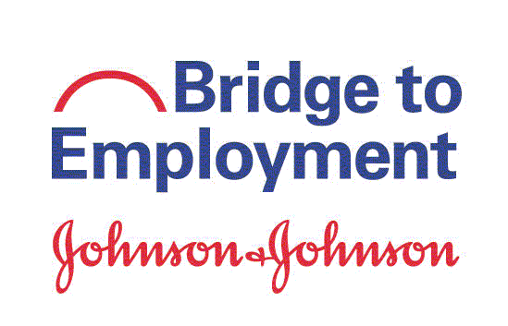

Alliance Building and Training Session (ABTS) 2018 Parent Consent Form
If selected as a Student Ambassador, your child will be attending the Alliance Building and Training Session (ABTS). Johnson & Johnson's Alliance Building & Training Session (ABTS) is an annual professional development, learning, networking, and cross-site sharing conference for Bridge to Employment (BTE) partners. This is not a school-sponsored event; it is hosted by FHI 360 and Johnson & Johnson. Approximately 80 local operating company representatives, educators, community leaders, and students from around the world gather to share experiences and learn about effective programs and best practices. Student Ambassadors are an integral component of the ABTS.

Date | October 6-9, 2018
Location | Lisbon, Portugal
Cost | FHI 360 will cover travel costs associated with ABTS attendance, including  transportation, lodging, meals, and health insurance.
Transportation | Students will travel by air; local BTE personnel will serve as chaperones and supervise students at all times during travel to and through the ABTS.

Please return this permission slip by: March 22, 2018

I give permission for my child
to attend ABTS from October 6-9, 2018 in Lisbon, Portugal. I approve of my child traveling under the supervision of BTE personnel. I acknowledge that the ABTS is not a school-sponsored event and understand that my child may incur unexcused absences from school for his/her participation.
In case of an emergency, I give permission for my child to receive medical treatment. In case of such an emergency, please contact:

Print Name

Phone Email:

Parent/Guardian Signature Date



Permission to Use Pictures and/or Story

AGREEMENT
I agree to allow FHI 360 and/or its partners to publish, copyright, and use pictures of me and/or my story in print and electronic formats such as publications, videos, projects, and websites that help advance public health and development initiatives. I understand that my picture or story may be published in any of these media without restriction.

I understand that I will not receive payment or other compensation for use of my story or photos.

Signature | Date
Print Subject’s name
Subject’s Address
Parent/Legal Guardian (if under age 18) | Date
Photography Date

FHI 360 is a trade name of Family Health International

