HOW SOLID WASTE CONTRIBUTES TO POLLUTION
BTE- Bogotá, Colombia Student Findings
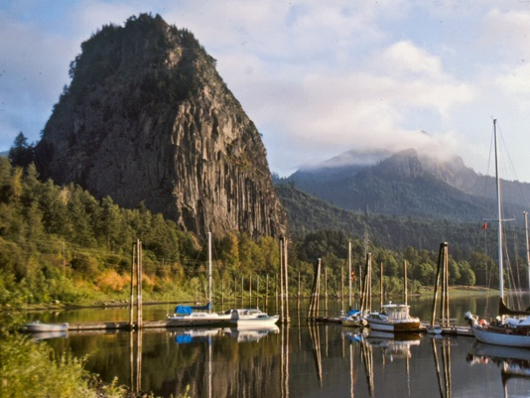
From the point of view of developing countries, they are the victims of global warming, but at the same time, they also represent the salvation of the planet due to their vast jungles and forests. However, it should be made clear that all countries are responsible for global warming. The influence of waste and greenhouse gases on global warming should be analyzed. When decomposing, wastes (especially organic ones) generate two very aggressive components for the environment: gases that go to the atmosphere and leachates that go to the ground. Among the gases that decomposing waste produces, we find carbon dioxide (CO2), nitrous oxide (N2O), and methane (CH4). These are greenhouse gases.
Modern cities are characterized by large conglomerations of people and accumulations of waste. These facts show the inability of traditional methods of waste treatment to solve the problem. According to several studies, waste production in the world is greater than (by year, weight, and volume) the sum of the production of all the industries together.
World rubbish (trash) produces 44,000 million cubic meters of biogas per year. This is the human contribution to global warming.
One ton of organic waste produces 40 meters cubed of biogas. The world produces 5 million tons of rubbish per day; this is equivalent to 25 million m3 of biogas, which can occupy 343 city blocks as high as 3 floors. Consequently, each year, rubbish can occupy 125,195 city blocks with a height of 3 floors; this is equivalent to 80,124 hectares.
In 1995, a study was published about families that lived close to an important municipal solid waste landfill: the Miron Quarry in Montreal, Canada. This landfill operated between 1968 and 1990 and is the third-largest landfill in North America. In this area, researchers found a large number of cases of stomach, liver, prostate, and lung cancer among men, and cervix and uterine cancer among women.
More research by the New York Health Department in 1998 examined the number of types of cancer among men and women who lived close to 38 landfills, where evidence found that there was contaminating gas in the air as a result of the waste’s chemical reactions.
Out of the 14 patients consulted for the research, the study showed that in 10 cases, there was a higher incidence of cancer, but only 2 types of cancer (bladder cancer and leukemia in women) were statistically significant. The study concludes that for women who lived close to the landfills, there was a higher incidence of 7 different types of cancer. In men, the study determined that there was a higher prevalence of (though statistically insignificant) lung cancer, bladder cancer, and leukemia.

In August 2001, research was published in the United Kingdom about the effects of living close to landfills on people’s health. After studying 9,565 landfills, the research showed that the risk of malformations increased by 1% for those living within a distance of 2 km from a landfill. Some abdominal malformations were 8% more frequent in zones next to the landfills. [1]
It is well-known that in 50 years, the temperature of the Earth will increase by 2 degrees due to global warming. This will cause, among other phenomena, an increase in ocean levels, which will cause the loss of ecosystems, cities, and even countries. Examples of this are the Maldives in the Indian Ocean and Tuvalu in the Pacific, which will have to be evacuated in a few decades as they will be completely submerged in water. Once this happens, there is no way of reversing the effects.
Human activities are negatively affecting the planet and the life on it, and it is very clear how. Greenhouse gases produced by the excess consumption by societies, especially in rich countries, have led gases to accumulate in the atmosphere. The heat is unable to leave the planetary surface and is trapped in, like a greenhouse. This phenomenon is called global warming or climate change, and it is causing slowly rising temperatures on Earth and in the oceans, which will affect the weather, incidence of storms, and ecosystems in the future.
Scientists have alerted the world about the need to make changes in habits and practices such as: reducing energy consumption, avoiding the use of oil and coal, stopping deforestation, improving cattle management (since they liberate great amounts of methane through their digestion), and reducing car use. These are some of the opportunities that humankind has to stop the problem. But this issue is not as simple as it seems. Many companies and countries that pollute the environment or sell products that cause global warming do not want to stop their activities because of the profits they generate. These companies have convinced politicians that the problem is not so severe. Politicians met in Copenhagen to discuss this problem in hopes of signing economic agreements. They expressed their concern, but they were unable to come up with concrete agreements to decrease the concentration of greenhouse gases in the atmosphere.
The countries with the highest levels of gas emissions are China, the United States, Russia, Canada, and Australia, among others. These countries want to continue their gas-issuing activities because they claim that their economies need to continue growing. Some of them even expect that less developed countries should be able to preserve their ecosystems without any type of financial support. The truth is that gas emissions keep increasing, as well as the incidence of natural disasters.
Some Latin American countries have taken action to save water and energy. Colombia is also at risk of having to do so.

