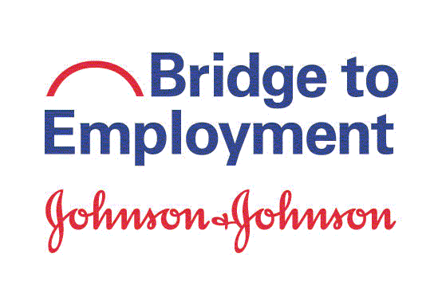

Thank you for taking this survey!

Instructions. Please take a few minutes to answer these questions. The information you provide will help improve the BTE program. Your individual information will be treated confidentially. Thank you!

About You

- What kinds of grades do you get? (check the one that you get in most of your school subjects)
Mostly As or 90% - 100%
Mostly Bs or 80% - 89%
Mostly Cs or 70% - 79%
Mostly Ds or 65% - 69%
Mostly Fs or below 65%

- Do you participate in any activities other than BTE? (check all that apply and write the name of each activity)
Clubs:
(for example, Boy Scouts, music/drama, math, language)
Religious activity:
Sports team:
Part-time job:
Tutoring:
Volunteering:
Other:
None (I do not participate in any activities outside of school)

next page . . .

- Is there an adult that you talk to about careers and ask for career advice? (check one)
- Yes | - No (go to Question 4)
3a. If yes, is this person an employee at Johnson & Johnson?
  - Yes
  - No
  - Don’t Know

Your Thoughts

- To what extent do you disagree or agree with the following statements? (Put an X in the box that describes how you feel.)

 | Strongly  Disagree | Disagree | Agree | Strongly Agree
- I am aware of the educational opportunities available to me after high school / secondary school.
- I am aware of different careers in the health industry.
- I know the skills needed for health careers.

next page . . .

- To what extent do you disagree or agree with each of the following statements? (Put an X in the box that describes how you feel.) Note: The term “higher education” means education beyond high school/secondary school; for example, a vocational school, trade school, college or university.

I am confident in my ability to . . . | Strongly  Disagree | Disagree | Agree | Strongly Agree
- Use my knowledge and skills to achieve my educational goals
- Identify my goals for the next five years
- Determine the steps I need to take to attain my goals
- Reach my goals, even if I sometimes get frustrated
- Find out about different careers
- Talk with a person who has a career that I am interested in
- Choose a career that fits my interests
- Understand the steps / process I need to take to get into higher education
- Apply to a higher education institution
- Attend higher education
- Prepare a good résumé / CV
- Interview for a job

next page . . .

Your Skills S

- The following are critical skills and abilities needed for many jobs. How bad or good are you at each of the following skills? (Put an X in the box that describes your abilities.)

 | Very  Bad | Bad | Good | Very Good
- Making decisions
- Managing time
- Leading a group
- Working independently/on your own
- Working with others
- Asking questions and gathering information to solve problems
- Reading and understanding written text/instructions
- Writing reports and papers
- Making presentations
- Solving problems
- Innovating (having new ideas)
- Solving math problems
- Conducting science labs/experiments
- Using computer programs like Word, Excel or PowerPoint

next page . . .

Your Plans

- What are your immediate plans after graduating from secondary school? Note: The term “higher education” means education beyond high school / secondary school; for example, a vocational school, trade school, college, or university. (check all that apply)

- Get a job (describe the job)
- Join the military
- Attend a higher education institution (list major / field of study)
- Other: (describe)

- Don’t know

--If you checked off above that you plan to attend a higher education institution immediately after graduating from secondary school, please go to question 7a.

--If you did not check off above that you plan to attend a higher education institution immediately after graduating from secondary school, please skip down to question 8 on the next page.

7a. What type of higher education institution are you planning to attend? (check all that apply)
    - 4-Year College / University
    - 2-Year Community College
    - Vocational / Technical School
    - Certificate Program
    - Don’t know

7b. Have you done any of the following activities that will help you attend a higher education institution? (check all that apply)

Find out what I need to do to attend a higher education institution

Take an entrance exam

Submit an application to a higher education institution

Register / Enroll in a higher education institution

Complete paperwork to obtain financial assistance

Other: (list)

None (I have not done anything)

7c. If you have applied to at least one higher education institution, what is your acceptance status? (check one)

I have been accepted by at least one higher education institution

I have not (yet) been accepted by at least one higher education institution

next page . . .

7c1. If you have been accepted by at least one higher education institution, what is the name of the institution you will attend? (please write the name; if you do not know yet, please write “don’t know”)

- Do you plan to have a career (job) in the health or science field? (check one)

- Yes: | - No: | - Unsure:
If yes, what type of job are you interested in?  - (Describe the job) | If no or unsure, what are your reasons for not wanting to pursue a health/science career? (check all that apply)  - I want to do something else (describe)  _  - I don’t know enough about jobs in the health/science industry  - I think higher education/training costs too much  - I think health/science career salaries are too low  - My grades are not good enough  - I do not have the skills needed  - My personality is not a good match for a health/science career  - I think training/preparation for a health/science career takes too long  - I think a health/science career is too difficult for me  - Other: (list)

next page . . .

Your BTE Experiences

- To what extent do you disagree or agree with the following statements? (Put an X in the box that describes how you feel.)

 | Strongly  Disagree | Disagree | Agree | Strongly Agree
- The BTE program has improved my knowledge of why science and math skills are essential to getting a job in the health industry.
- The BTE program has increased my awareness of jobs in the health industry.
- The BTE program has increased my awareness of jobs in the science/math fields.
- The BTE program has made me aware of the steps I need to take to work in the health, science or math fields.
- The BTE program has motivated me to work harder in school.
- The BTE program has helped me to feel good about my future.
- The BTE program has prepared me to achieve my career goals.

- To what extent do you disagree or agree with the following statement? (check one)

The BTE program provided an advantage for me when I applied to higher education or a job.

- Strongly disagree
- Disagree
- Agree
- Strongly agree
- Not applicable – I have not applied to higher education or a job

You’re done! Thank you!

